-"Nations flourish when exports soar and imports enrich."

**Project Details:**

Project Demo URL: <https://portal.azure.com/#home>  
  
Static Website URL: <https://skillstorage07.z13.web.core.windows.net/>  
  
Youtube Video URL : <https://www.youtube.com/watch?v=Gzh3GoutcPI>  
  
GIT HUB URL: <https://github.com/alekyagummala/Explore-Skills_Azure>  
  
Industry: Business (Explore the enrich)

**Team & Responsibilities:**

**1. Gangadhari Nagaraju:**

Developer of the project. Created the website and managed the website using HTML, CSS, and Javascript.

**2. Muktapuram Geethanjali:**

Development, deployment, Static website in Azure portal.

**3. Domakonda Pavan:**

Developed the project. Data collection,Done the entire process.

**4. Kodidala Saddam Hussain:**

Documentation and content collection of the project.

**AZURE CORE SERVICES USED:**

Azure Storage  
  
Azure containers  
  
Azure backup  
  
Azure RBAC which is a role-based access service

**AZURE AI SERVICES USED:**

Azure Bot Service

**PROBLEM STATEMENT:**

International export and import activities play a crucial role in the global economy, facilitating the exchange of goods and services across borders. However, these transactions are not without challenges, and various issues can arise, creating complex problem statements for businesses and governments involved in international trade.

One significant problem faced in international trade is the existence of trade barriers. These barriers can take the form of tariffs, quotas, and non-tariff barriers, hindering the smooth flow of goods between countries. Tariffs, or taxes on imported goods, can increase the cost of products, affecting competitiveness and pricing strategies. Quotas, which limit the quantity of specific goods that can be imported, create supply constraints and can lead to market distortions.

Additionally, non-tariff barriers, such as technical regulations and standards, pose challenges for exporters in adhering to diverse and sometimes conflicting requirements across different markets. Meeting these standards can be costly and time-consuming, particularly for small and medium-sized enterprises (SMEs) with limited resources.

Furthermore, logistical challenges in transportation and infrastructure can impede the efficiency of international trade. Delays in customs procedures, inadequate transportation networks, and inefficient port facilities can result in increased lead times and higher costs, affecting the competitiveness of goods in the global market.

The complexity of international trade regulations and the lack of harmonization among different legal systems pose a legal challenge. Navigating through diverse legal frameworks requires significant expertise and resources, and failure to comply with regulations can lead to legal disputes and financial penalties.

In conclusion, the international export and import landscape present multifaceted challenges, ranging from trade barriers and exchange rate volatility to logistical and legal complexities. Addressing these issues requires coordinated efforts from governments, businesses, and international organizations to create a more transparent, predictable, and efficient global trade environment.

Top of Form

**PROJECT DESCRIPTION:**

Welcome to our Hanuman International Exports and Imports , your gateway to seamless international export and import solutions. Our platform is designed to empower businesses by providing a comprehensive and user-friendly interface for navigating the complexities of global trade. Whether you are a seasoned exporter or importer or just venturing into the world of international commerce, our website is your one-stop destination for a streamlined and efficient trading experience.

One of the primary motivations for engaging in international trade is the opportunity for businesses to tap into new markets and diversify their customer base. By exporting goods or services to foreign markets, companies can access a larger pool of potential consumers and reduce their dependence on a single market. Importing, on the other hand, allows businesses to gain access to resources, raw materials, or finished products that may not be readily available or cost-effective in their domestic markets.

In conclusion, while international export and import activities offer immense opportunities for businesses to expand and thrive, they also present a complex array of challenges that require strategic planning, adaptability, and a deep understanding of the dynamic global trade environment. Navigating these challenges successfully can lead to enhanced competitiveness, increased market reach, and sustainable growth for businesses operating on the international stage.

Embark on your international trade journey with confidence and ease. Hanuman International Exports and Imports is here to elevate your business to new heights in the global marketplace. Join us today and unlock a world of opportunities!

**AZURE CORE AZURE SERVICES:**

[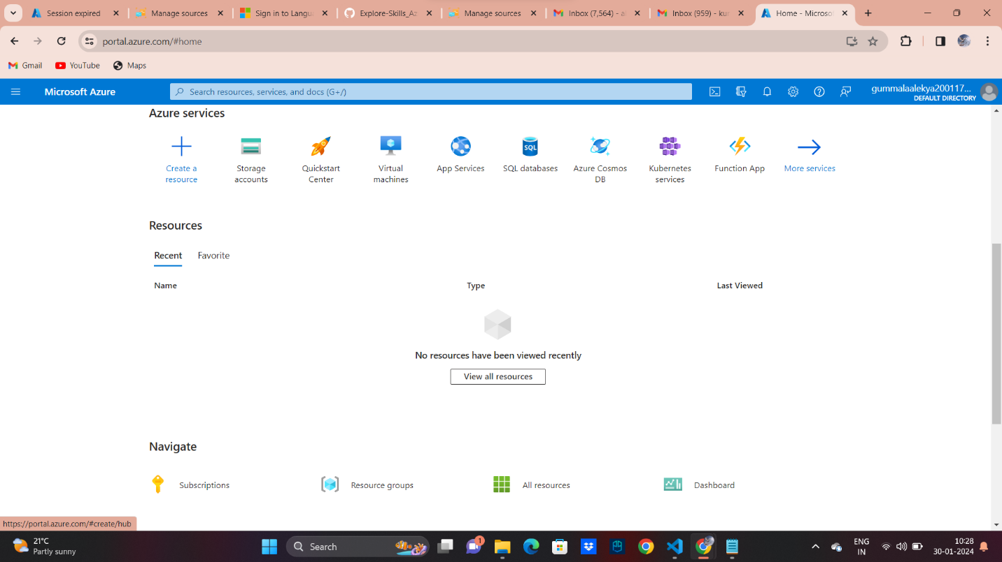](https://github.com/alekyagummala/Explore-Skills_Azure/blob/main/index_az.png)

**Azure Storage Account:**

Azure Storage Account is a cloud-based storage solution provided by Microsoft Azure, a leading cloud computing platform. It serves as a scalable and secure repository for various types of data, offering a range of storage services to meet diverse application needs.

[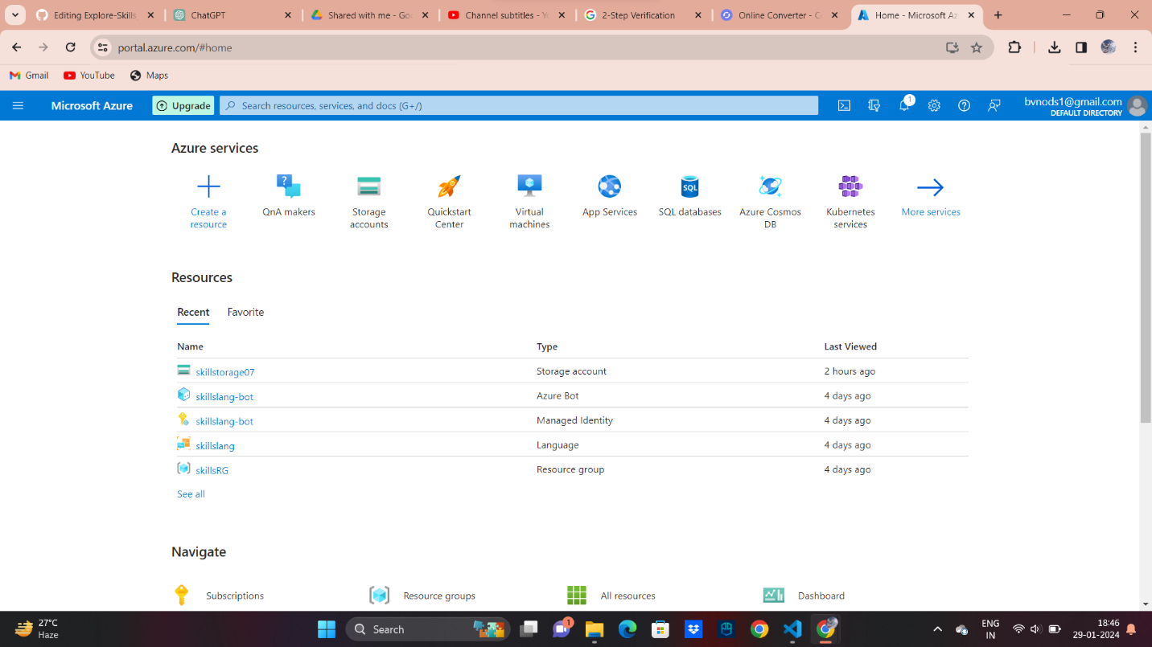](https://github.com/alekyagummala/Explore-Skills_Azure/blob/main/servies.png)

**Azure Blob Storage:**

Azure Blob Storage is a cloud-based object storage service in Microsoft Azure, designed for storing and managing large amounts of unstructured data, such as documents, images, and videos. It provides scalable and secure storage, supporting different access tiers based on data usage patterns. Blob Storage is commonly used for backup, data archiving, and serving content to web applications.

[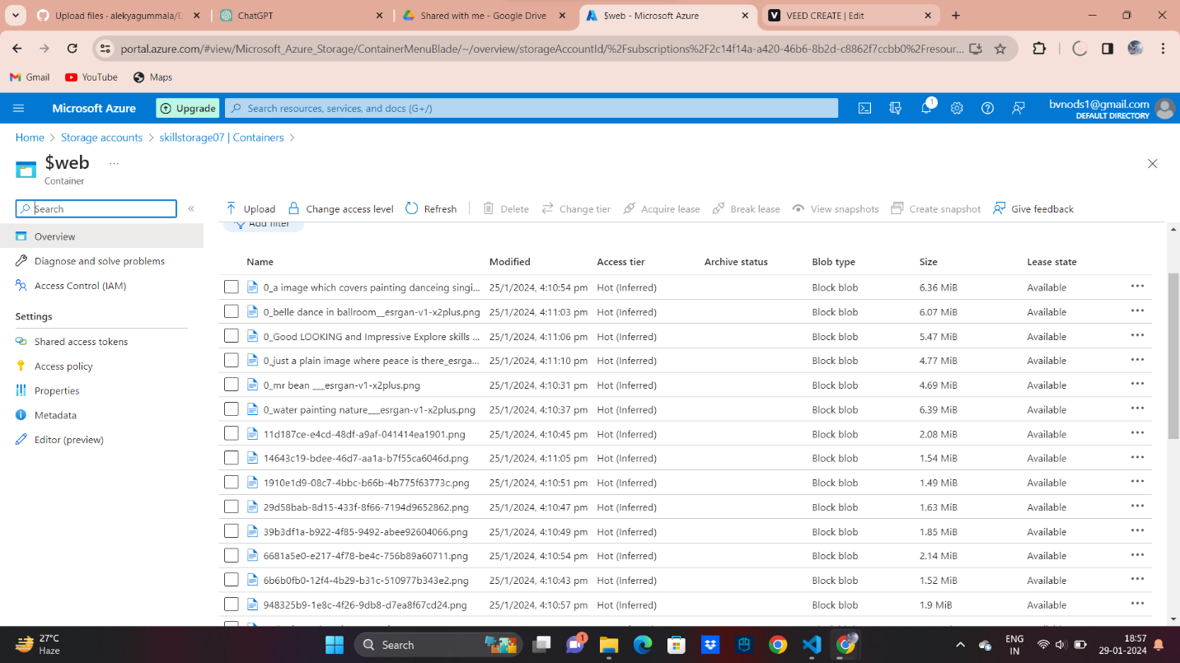](https://github.com/alekyagummala/Explore-Skills_Azure/blob/main/blob1.png)

**Azure Backup Service:**

Azure Backup Service is a cloud-based solution provided by Microsoft Azure that enables organizations to back up and protect their data and workloads in the cloud. It offers a reliable and scalable backup solution with features designed to safeguard critical information.

[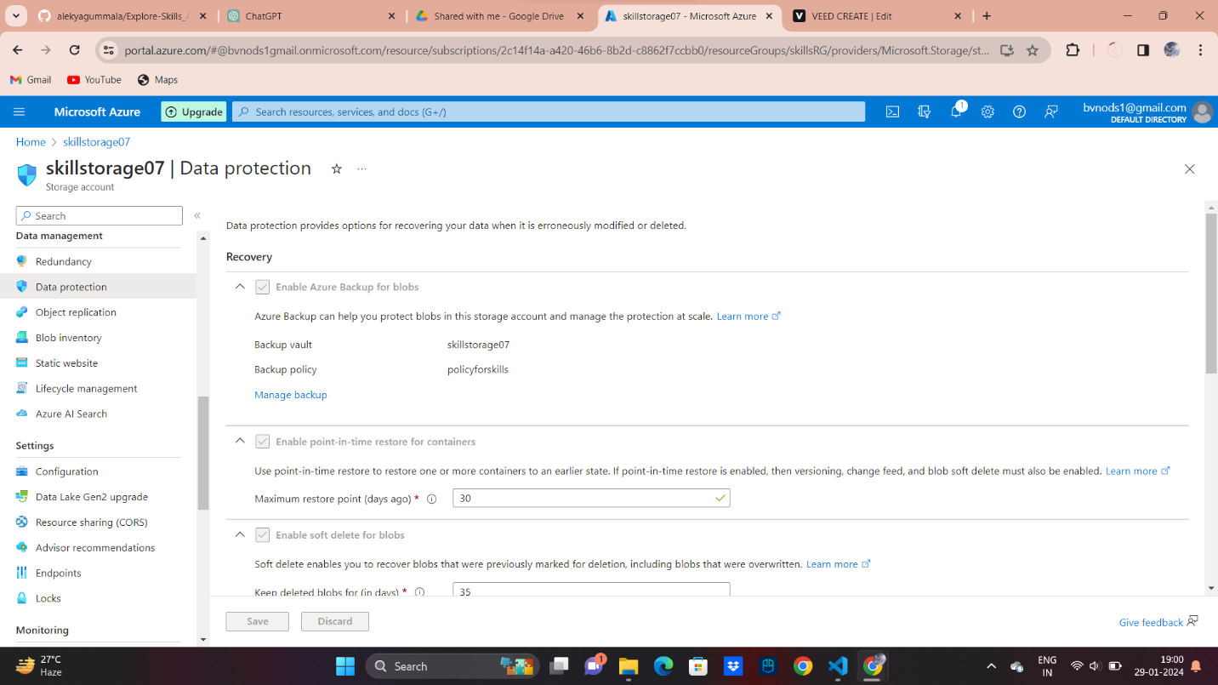](https://github.com/alekyagummala/Explore-Skills_Azure/blob/main/backup.png)

**Azure RBAC which is a role-based access service:**

Azure RBAC, or Role-Based Access Control, is a service provided by Microsoft Azure that helps manage and control access to Azure resources. It is a security model that allows administrators to define who (identity) can do what (actions) on specific resources in Azure. RBAC helps in implementing the principle of least privilege, ensuring that users have only the necessary permissions to perform their tasks and limiting the risk of unauthorized access.

[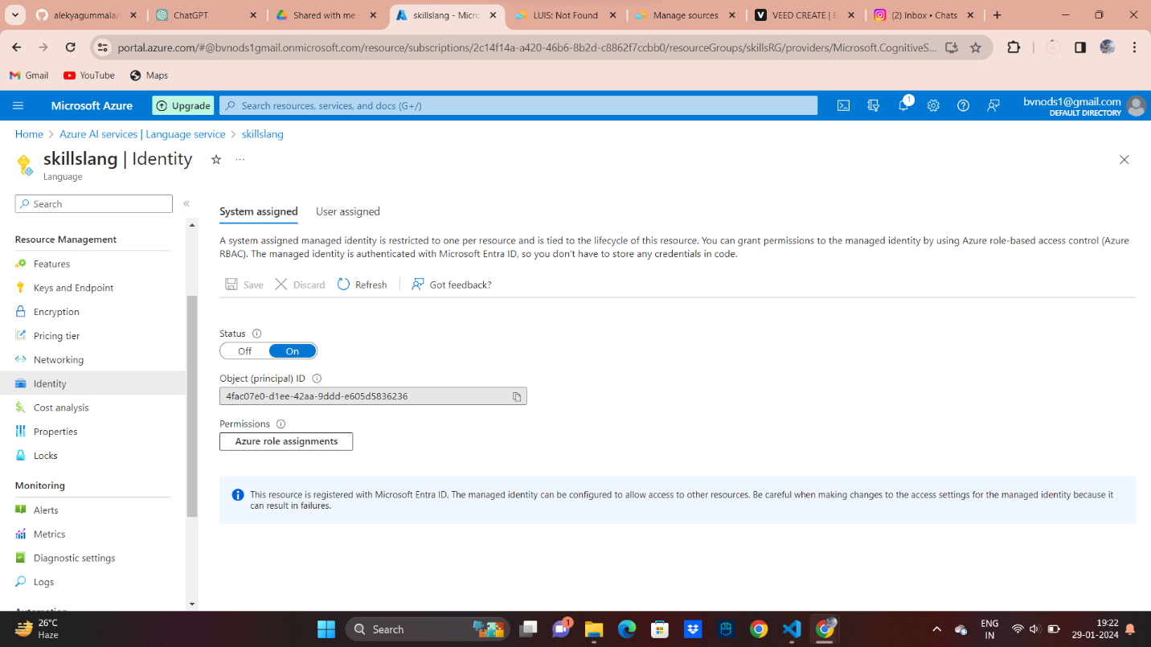](https://github.com/alekyagummala/Explore-Skills_Azure/blob/main/rolebased.png)

[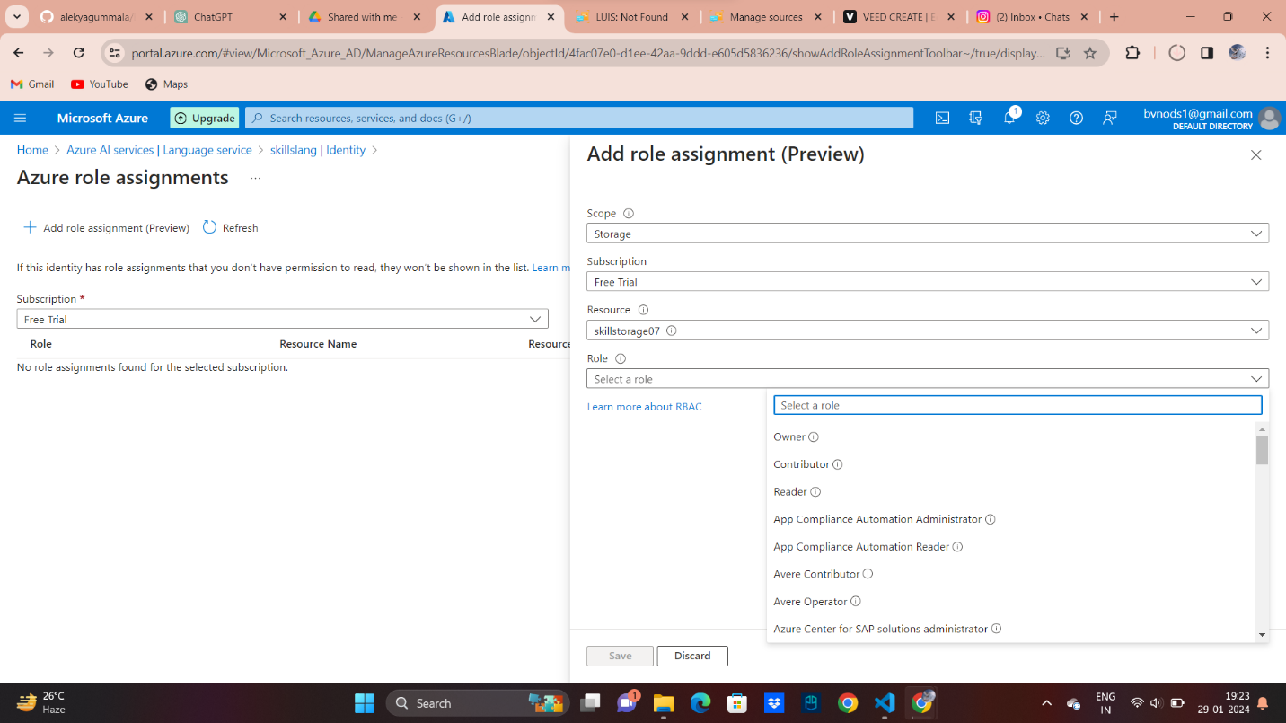](https://github.com/alekyagummala/Explore-Skills_Azure/blob/main/role1.png)

**AZURE AI SERVICES:**

**Azure Bot Service:**

Azure Bot Service is a cloud-based service provided by Microsoft Azure that enables the development, deployment, and management of intelligent bots. Bots created using Azure Bot Service can interact with users across various channels, such as web, mobile, Microsoft Teams, Skype, and more. [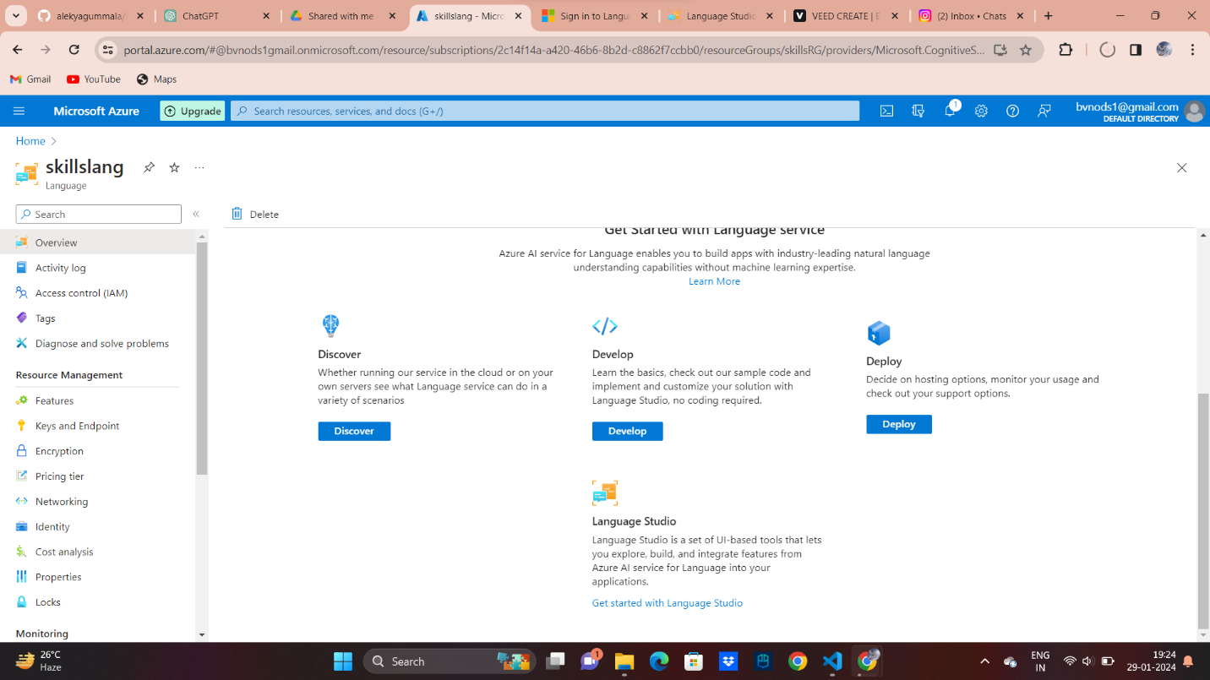](https://github.com/alekyagummala/Explore-Skills_Azure/blob/main/chat0.png) [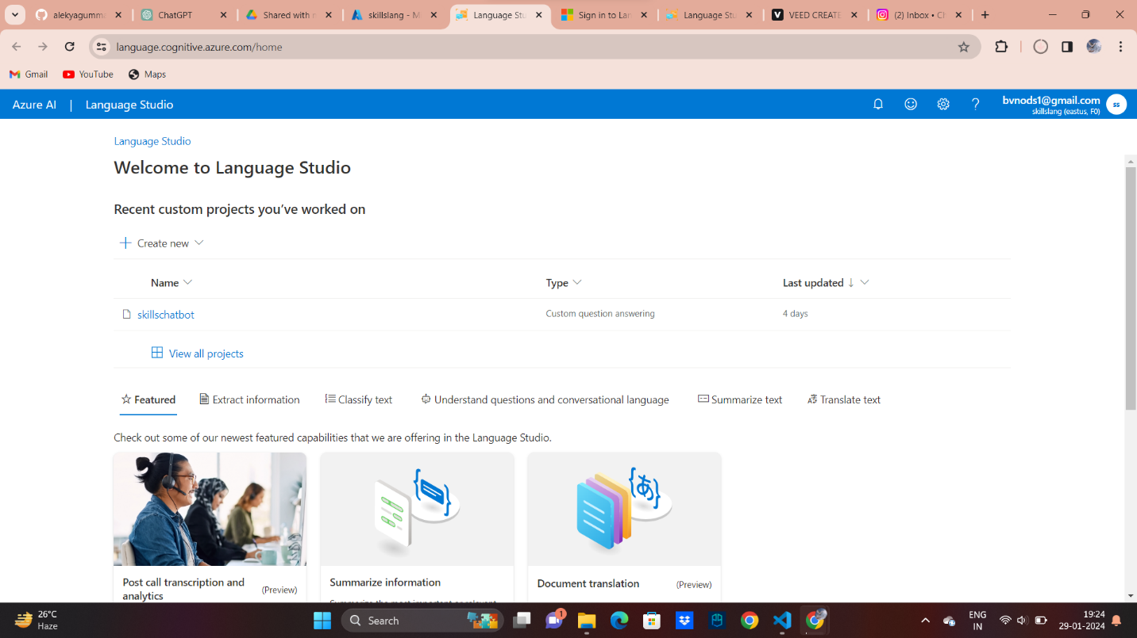](https://github.com/alekyagummala/Explore-Skills_Azure/blob/main/chat1.png) [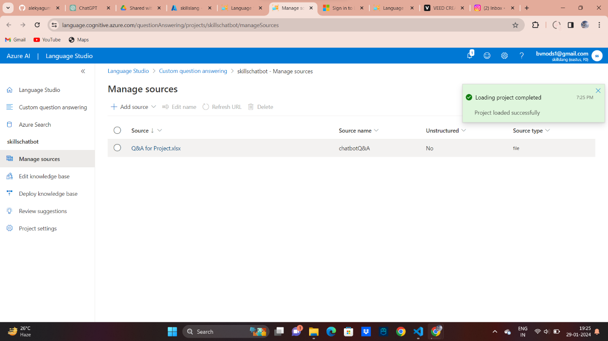](https://github.com/alekyagummala/Explore-Skills_Azure/blob/main/chatqa.png) [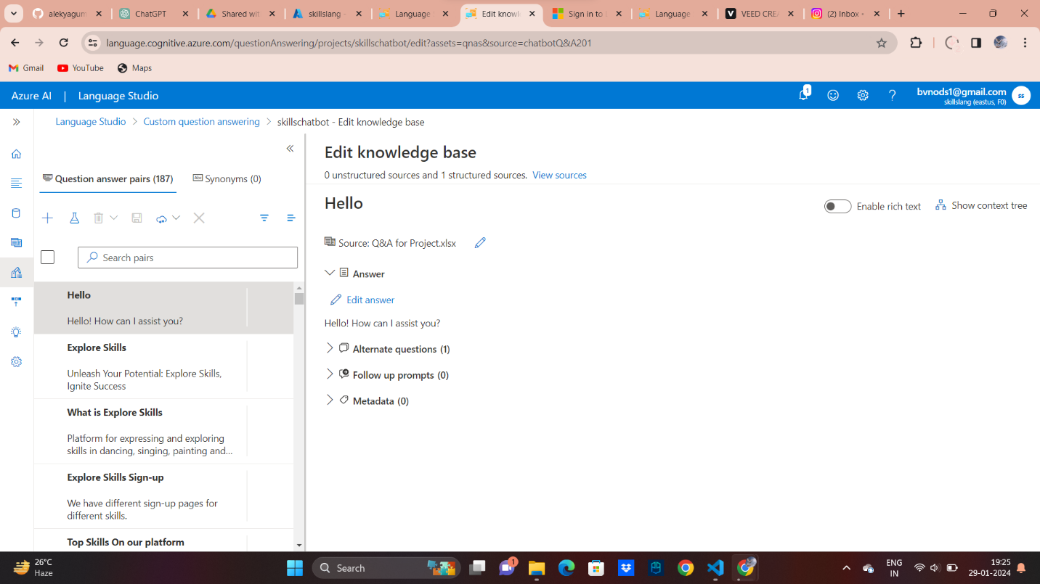](https://github.com/alekyagummala/Explore-Skills_Azure/blob/main/chatqa1.png) [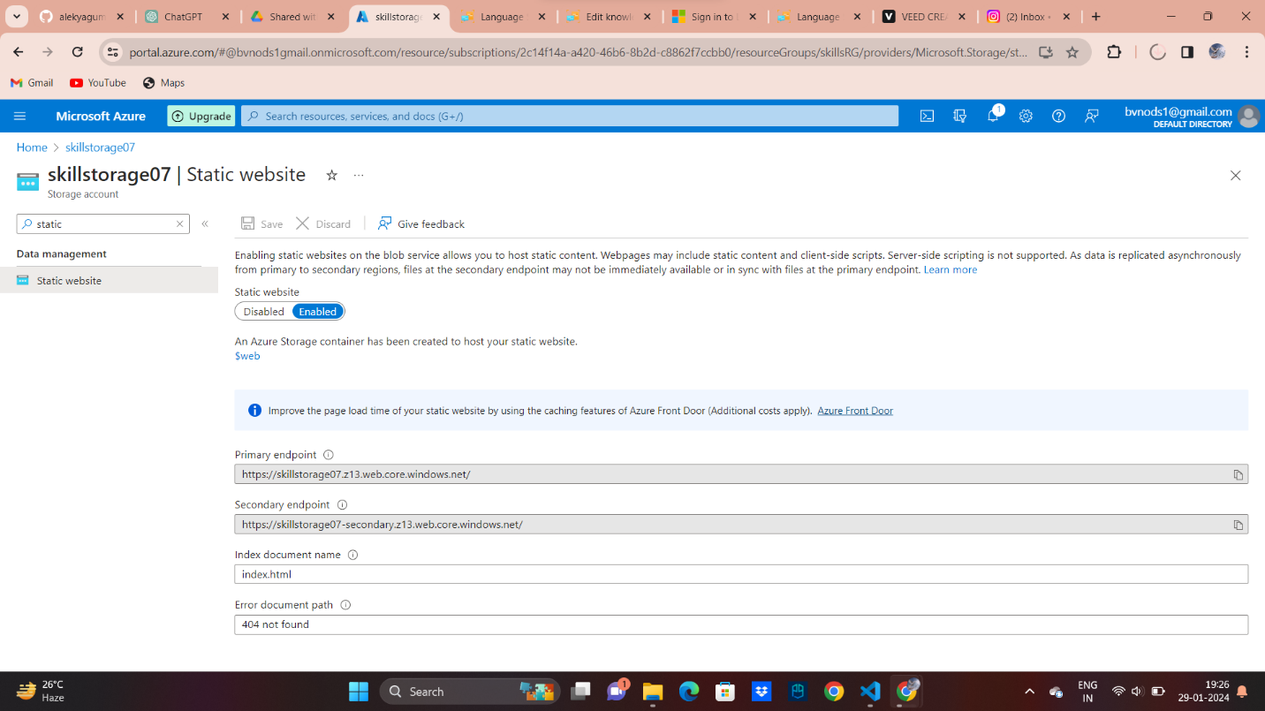](https://github.com/alekyagummala/Explore-Skills_Azure/blob/main/staticwebchat.png) [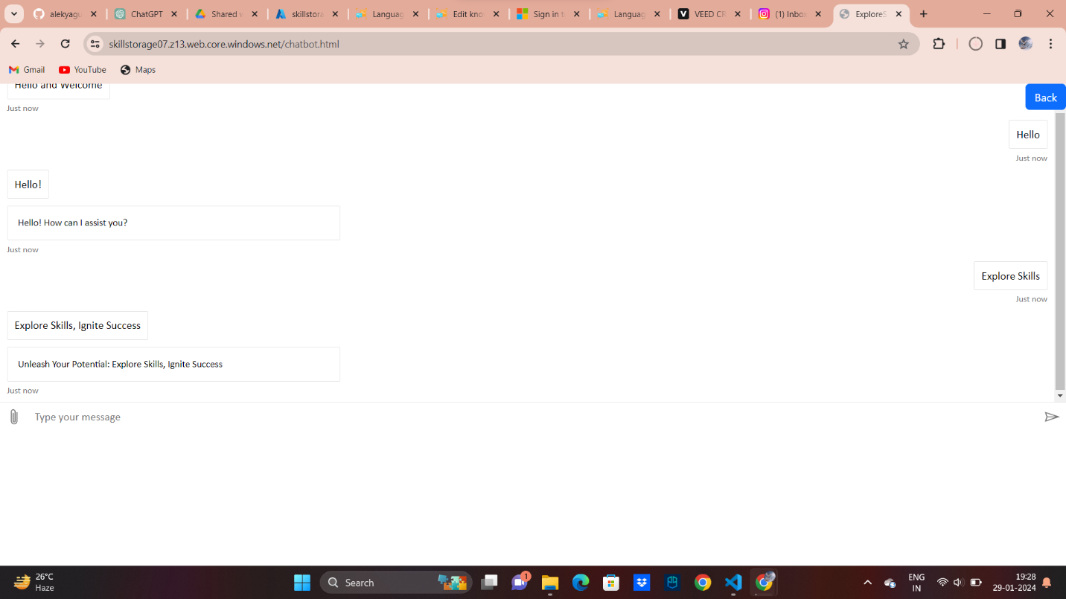](https://github.com/alekyagummala/Explore-Skills_Azure/blob/main/chatbot.png) [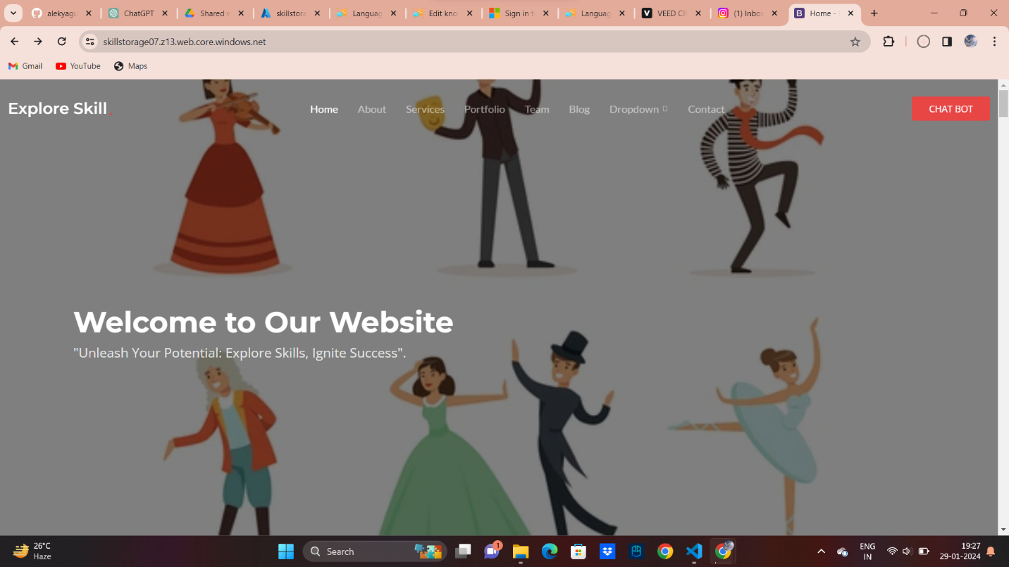](https://github.com/alekyagummala/Explore-Skills_Azure/blob/main/chatf.png)

**Manage Identity:**

Azure Managed Identity is a service in Microsoft Azure that enhances the security and ease of access to cloud resources by providing an identity management solution for applications and services.

[](https://github.com/alekyagummala/Explore-Skills_Azure/blob/main/rolebased.png)

[](https://github.com/alekyagummala/Explore-Skills_Azure/blob/main/role1.png)

**Azure AI Service**

Azure AI services encompass a suite of artificial intelligence (AI) offerings provided by Microsoft Azure, designed to empower developers and businesses to integrate AI capabilities into their applications and workflows.

[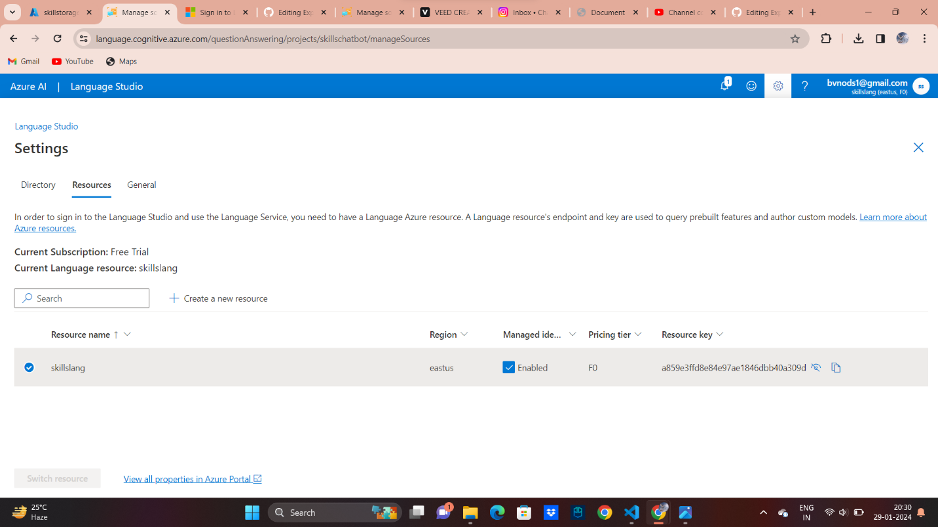](https://github.com/alekyagummala/Explore-Skills_Azure/blob/main/lang.png)

[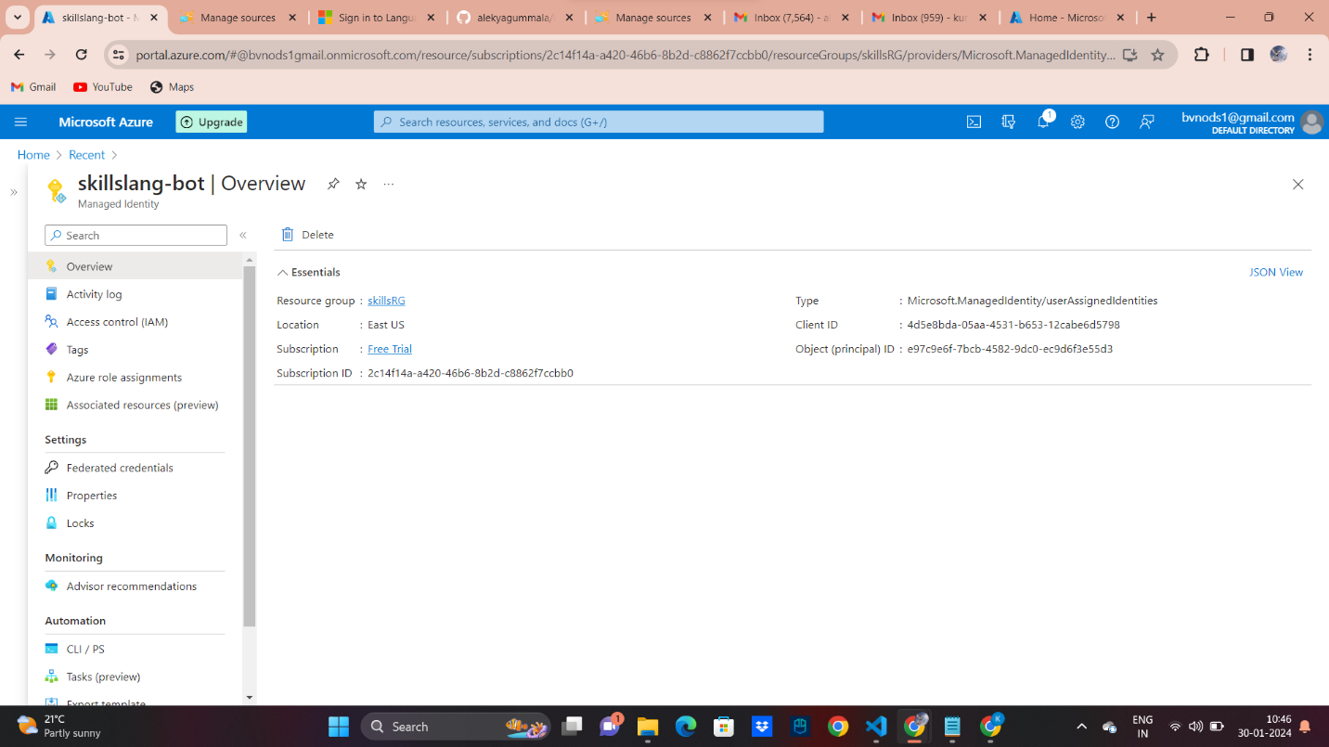](https://github.com/alekyagummala/Explore-Skills_Azure/blob/main/botlang.png)

[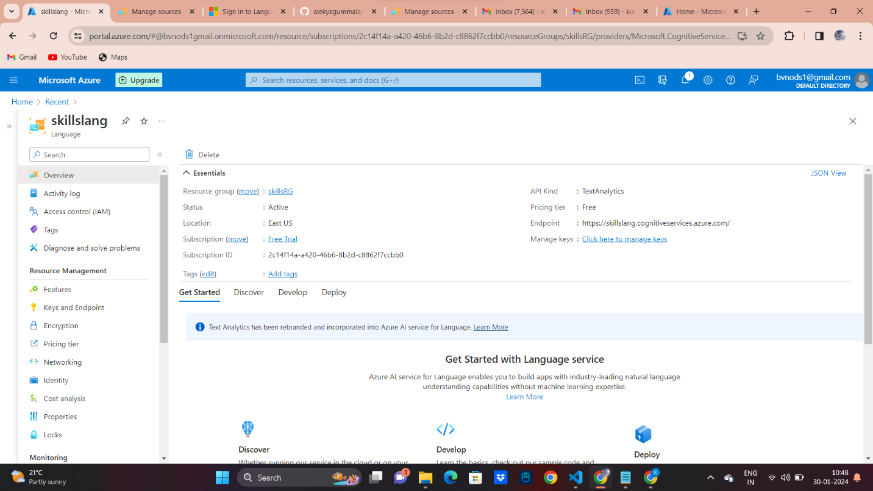](https://github.com/alekyagummala/Explore-Skills_Azure/blob/main/skillsbot.png)

**Search Service:**

Azure Search Service is a fully managed, cloud-based search-as-a-service solution provided by Microsoft Azure. It allows developers to integrate powerful search capabilities into their applications without the need for complex infrastructure or extensive search engine expertise.

[](https://github.com/alekyagummala/Explore-Skills_Azure/blob/main/chatbot.png)

**FINAL PROJECT STATEMENT**

Our comprehensive project on international export and import encapsulates a strategic commitment to fostering global economic connectivity and sustainable growth. By delving into the intricate dynamics of international trade, we aim to unlock opportunities for our organization and contribute to the broader narrative of economic prosperity.

On the export front, our project is designed to showcase the excellence of our domestic products and services on the world stage. Through meticulous market research, strategic partnerships, and adherence to international standards, we aspire to position our exports competitively, creating a positive impact on our nation's economy. Investments in logistics, technology, and export financing underscore our dedication to facilitating a seamless export process and empowering local businesses to thrive in the international market

[](https://github.com/alekyagummala/Explore-Skills_Azure/blob/main/chatf.png) [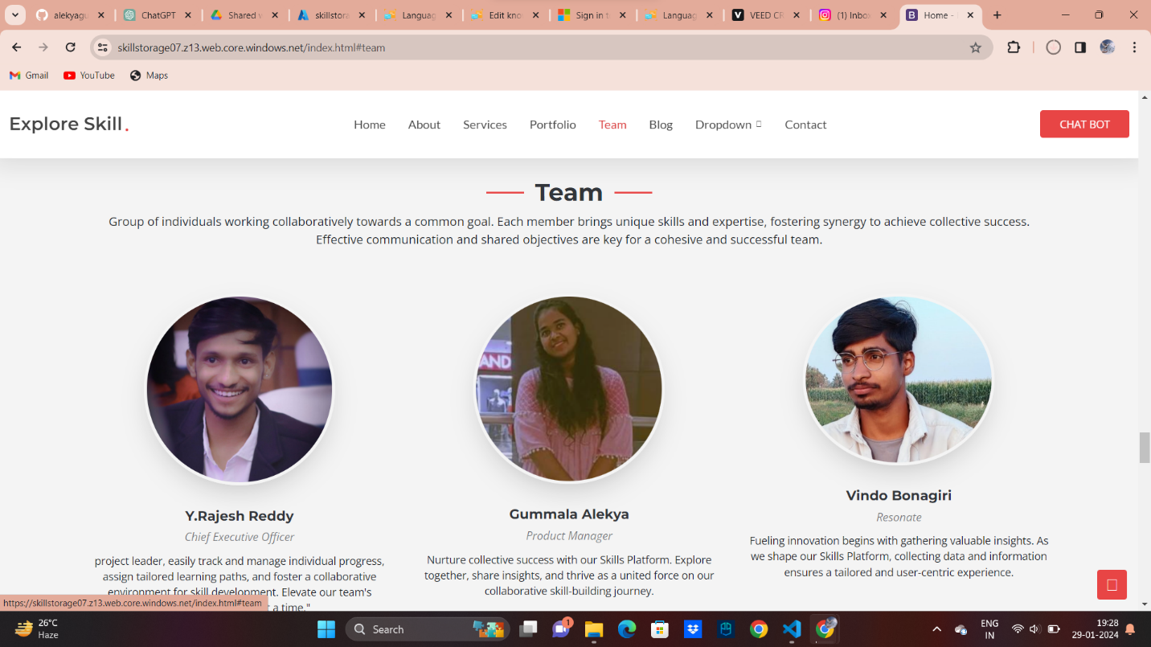](https://github.com/alekyagummala/Explore-Skills_Azure/blob/main/final1.png) [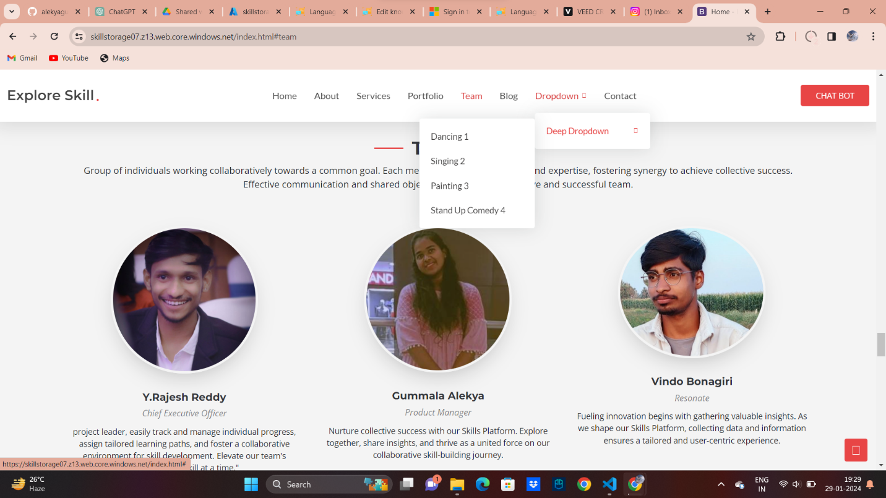](https://github.com/alekyagummala/Explore-Skills_Azure/blob/main/final2.png) [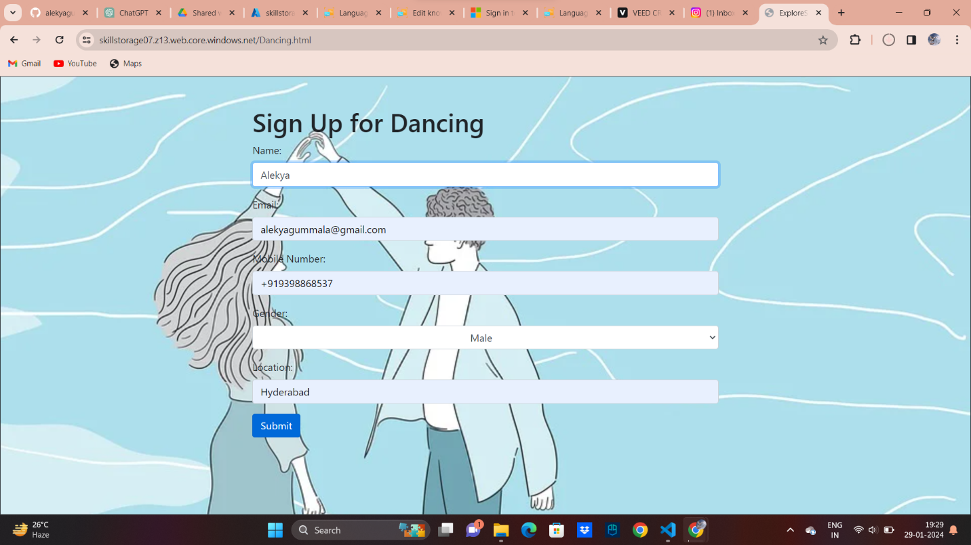](https://github.com/alekyagummala/Explore-Skills_Azure/blob/main/final3.png) [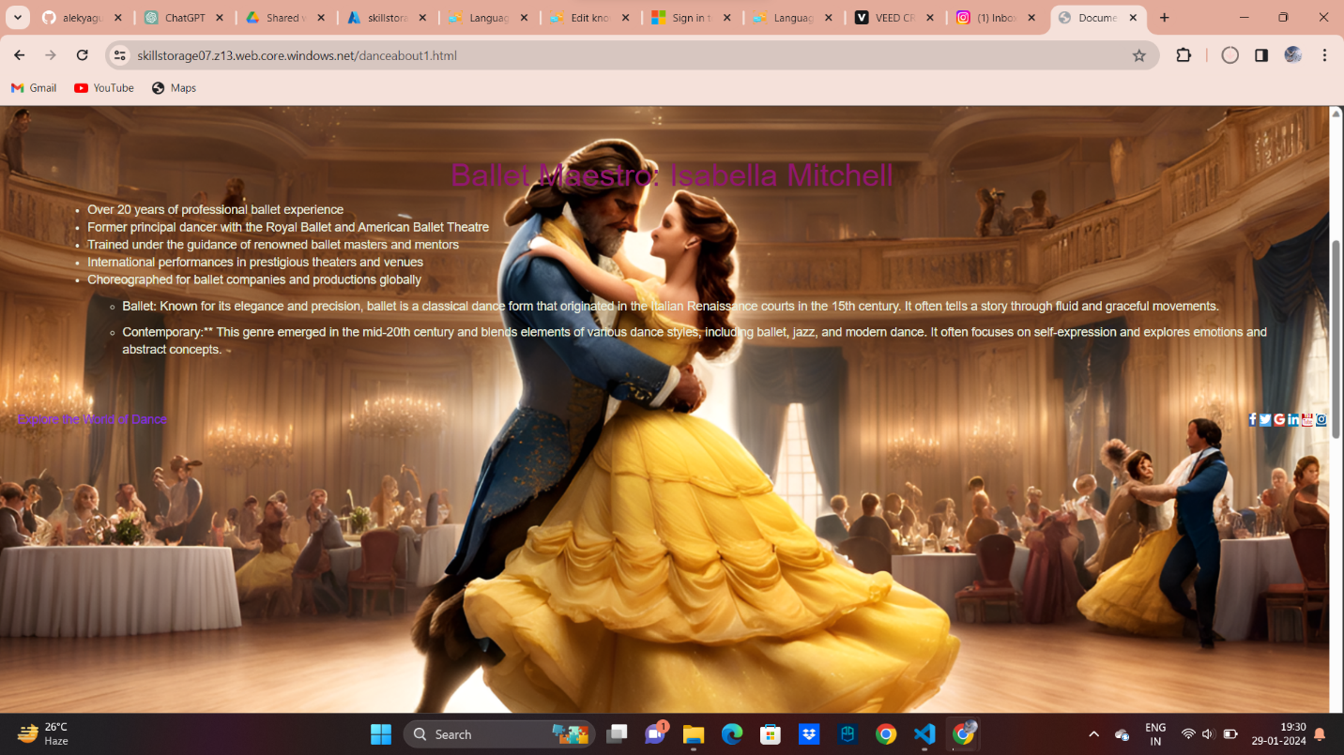](https://github.com/alekyagummala/Explore-Skills_Azure/blob/main/final5.png) [](https://github.com/alekyagummala/Explore-Skills_Azure/blob/main/final6.png)

**About**

"The Explore Skills website project is all about creating a new and exciting online learning platform". The main goal is to make a space that is dynamic and focused on users, helping people improve their skills in different areas. We know that learning online can be tricky, so our website will have carefully planned learning paths,interactive skill

[skillstorage07.z13.web.core.windows.net/](https://skillstorage07.z13.web.core.windows.net/)

**Topics**

[painting](https://github.com/topics/painting) [singing](https://github.com/topics/singing) [dancing](https://github.com/topics/dancing) [stand-up-comedy](https://github.com/topics/stand-up-comedy)

**Resources**

[Readme](https://github.com/alekyagummala/Explore-Skills_Azure#readme-ov-file)

[Activity](https://github.com/alekyagummala/Explore-Skills_Azure/activity)

**Stars**

[**0** stars](https://github.com/alekyagummala/Explore-Skills_Azure/stargazers)

**Watchers**

[**1** watching](https://github.com/alekyagummala/Explore-Skills_Azure/watchers)

**Forks**

[**0** forks](https://github.com/alekyagummala/Explore-Skills_Azure/forks)

[Report repository](https://github.com/contact/report-content?content_url=https%3A%2F%2Fgithub.com%2Falekyagummala%2FExplore-Skills_Azure&report=alekyagummala+%28user%29)

[**Releases**](https://github.com/alekyagummala/Explore-Skills_Azure/releases)

No releases published

[**Packages**](https://github.com/users/alekyagummala/packages?repo_name=Explore-Skills_Azure)

No packages published

[**Contributors4**](https://github.com/alekyagummala/Explore-Skills_Azure/graphs/contributors)

* [**alekyagummala**](https://github.com/alekyagummala)
* [**rajeshreddy07**](https://github.com/rajeshreddy07)
* [**WorldDarker** Vinod Bonagiri](https://github.com/WorldDarker)
* [**Manojkurma1803**](https://github.com/Manojkurma1803)

**Languages**

* [JavaScript44.4%](https://github.com/alekyagummala/Explore-Skills_Azure/search?l=javascript)
* [HTML32.3%](https://github.com/alekyagummala/Explore-Skills_Azure/search?l=html)
* [CSS23.3%](https://github.com/alekyagummala/Explore-Skills_Azure/search?l=css)